Halloween
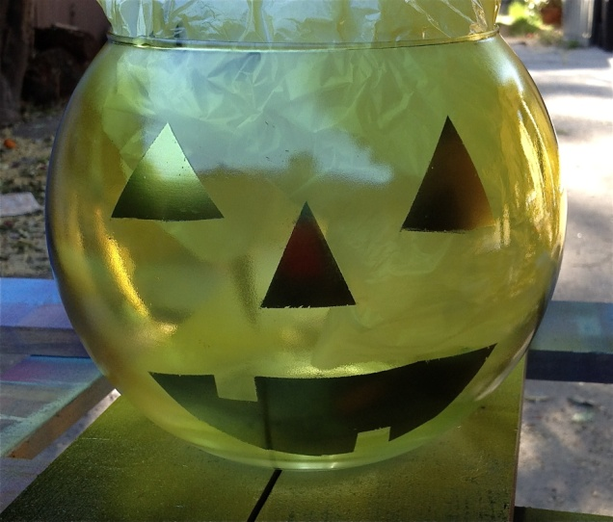

Materials: | Tools:
1" & 1 ½” ScotchBlue™ Edge-Lock™ 2080 | Respiratory Mask

Spray Paint designed to be used on Glass, in Chrome and Frosted Orange colours

Large Round Glass Bowl, or your shape choice

Plastic liner, garbage bag or shopping bags

Instructions:

Begin with a glass bowl of your choice; in this project a nice round one was chosen so represents the shape of a pumpkin.

Using 1” ScotchBlue™ Edge-Lock™ 2080 tape, begin laying out the face. Note: this design is made mostly of straight lines to help the tape provide a good seal along the curve of the surface.

TIP: When following a curved surface, hold the tape taught as you apply it. This will ensure you create a nice even seal. You will notice the other side of the tape may buckle, but concentrate on a nice tight seam with the tape and the image you are trying to create. When it is right – you will know. When it is wrong you will also know.

Here, we started with the eyes then worked our way down to the nose and mouth. Once the face design is created with the tape, Add lines all the way around to represent the wedges in the pumpkin; all with ScotchBlue™ Edge-Lock™ 2080 tape.

TIP: We did not take exact measurements, but created lines that felt natural. The less you think about it, the better it will turn out.

Once the areas you want to paint are masked out – cover the rest of the surface of the bowl with ScotchBlue™ Edge-Lock™ 2080 tape to prevent off-spray onto the glass. Be sure to cover the top opening as well!

Set your glass bowl on the plastic liner, garbage bag or series of opened shopping bags to protect surrounding surfaces.

Spray with chrome paint for glass surfaces.

TIP: When spray painting:
- Start spraying before your hit the surface you want to cover.
- Don’t have paint nozzle too close to the surface you are spraying.
- Keep spray can moving to prevent build up of paint, which will drips as it dries
- Light, even layers, are always best with sprays.

Once paint has fully dried, gently pull tape off by angling it at 45 degrees to reveal crisp edges, lines and corners.

Spray the entire outside of the bowl with orange frost paint; follow the tips for spray painting above, and allow to fully dry before handling.

